四年级英语（上）Unit3-4 测试题
听力部分
- Listen and choose. 听音，判断你听到的内容与图片是（√）否（×）一致，听2遍。（ 12分）
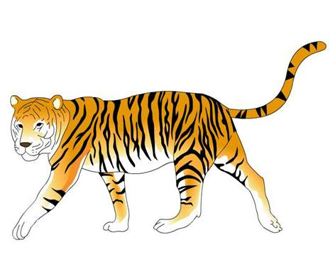
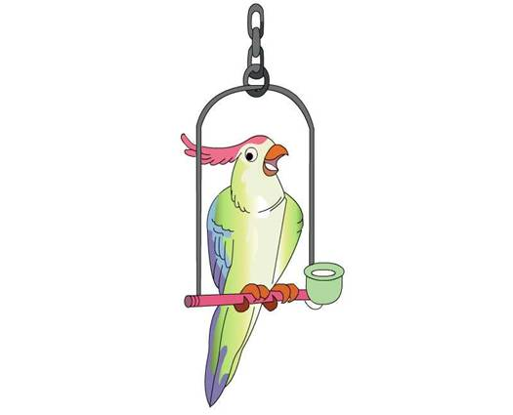
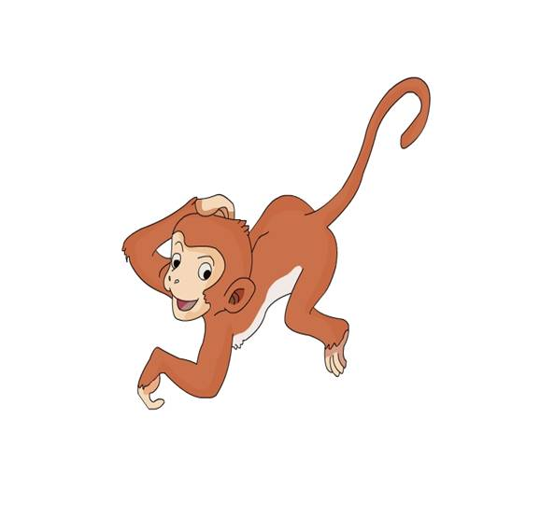
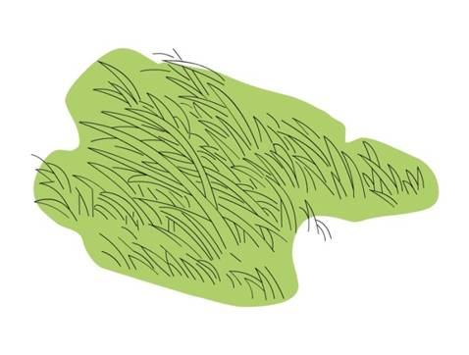
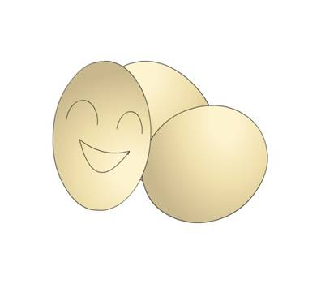
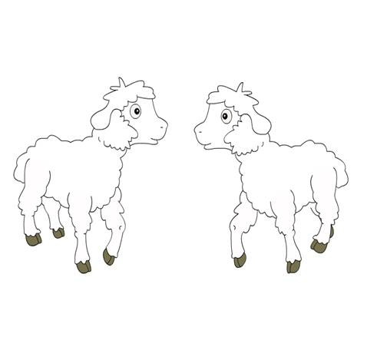

1.（ ） 2.（ ） 3.（ ） 4.( ) 5.（ ） 6.（ ）
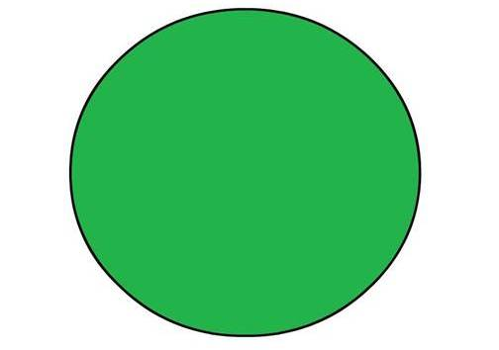
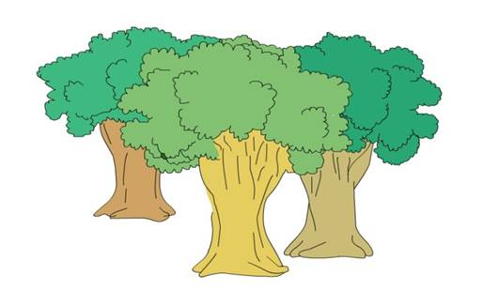
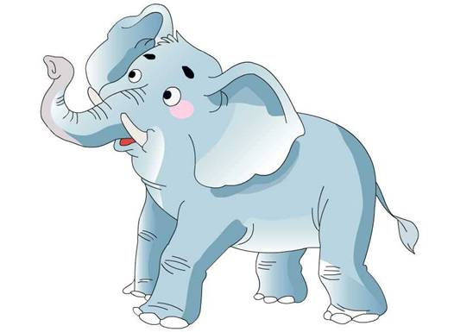

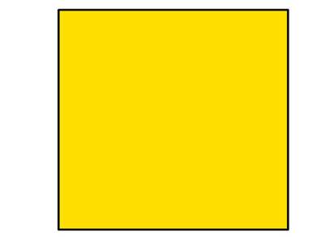
- Listen and number. 听音，选出正确的图片，听2遍 (8分)
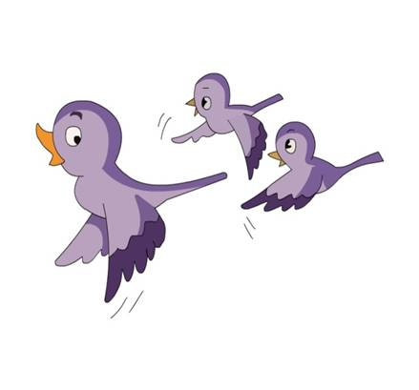
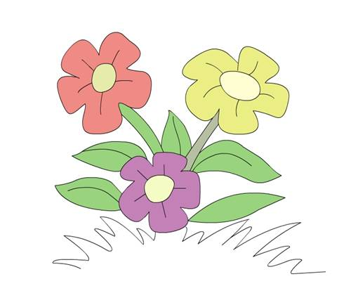
1． 2. 2.
A B A B A B A B
III. Listen and order 听音，给你听到的句子排序，听2遍。（ 10分）
( ) Look at the beautiful birds. ( ) Is that right?
( ) The children are on an outing. ( ) Don’t touch it! ( ) What are these?
笔试部分IV、图文匹配我在行。(20分)
A. dots B. monkey C. circle D. elephant E.grass F.bird G. eggs H. mouse
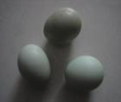
（ ） （ ） （ ） （ ） （ ） （ ） （ ） （ ）
VI. 找出每组不同类的项。(10分)
( ) 1. A. flowers B. trees C. sheep ( ) 2. A. circle B. line C. tree
( ) 3. A.funny B. bird C. monkey ( ) 4. A. big B. small C. bag
( ) 5. A.these B.that C.those
VII、选择对对碰。(10分)
( ) 1.Look____this elephant.It’s big. ( ) 2. What’s this? ---____ a tiger.
A.in B. on C. at A.It’s B. It C.There
( ) 3.The children ____on an outing. ( ) 4.They are _____eggs.
A．is B.am C. are A.bird B. birds’ C.bird’s
( ) 5.Is that right? No,_______ A. it isn’t. B. it is. C. they aren’t.
VIII、连线。(20 分）
1.How are you? A.I’m drawing.
2.What’s that? B.I’m fine
3.How many dots are there? C.It’s a cat.
4.What are you doing? D.Six.
5.Is that right? E.No,it isn’t.
IX .Read and judge. 阅读短文，判断正（√）误（×）。（20分）
Peter has a big zoo. There are many animals in the zoo. There are ten funny monkeys. There are five baby elephants. There is a strong tiger. There are nine beautiful birds. There is a cute panda. But there is not a mouse in the zoo.
1. Peter has a little zoo. ( ) 2.There are ten funny monkeys in the zoo. ( )
3.There are five mother elephants. ( ) 4.There are nine beautiful birds. ( )
5.There is a mouse in the zoo. ( )
I． 1. a small mouse 2.a funny monkey 3.a beautiful bird
4.trees 5. grass 6. flowers
II. 1. eggs 2.trees 3. a big elephant 4.circle
- 1. What are these? 2. The children are on an outing.
3.Look at the beautiful birds. 4.Is that right?
5.Don’t touch it!

